October 31, 2012

To the members of the Lake Minnewashta Preservation Association Board

I’m pleased to submit my report for our AIS Awareness Program we initiated this summer. The specific achievements are contained below, including pictures of DNR approved deliverables. Overall, we were very successful in completing the program in its entirety and under the budget we anticipated.

We enlisted 3 college interns from the University of Minnesota to greatly assist with the tactics of this program. It would have been difficult to achieve our results without their focused and dedicated help. Soliciting University of Minnesota college students for our internship was key for our program success. They provided the ‘feet on the street’ that allowed us to devote the time to develop the material for the program that we wouldn’t have been able to achieve with just a volunteer staff.

All of our board members were active in supporting the multiple efforts, particularly the AIS Road shows. They also provided ideas, guidance, and the many hours to support the various aspects of our program.
They considered this program key to our ability to keep zebra mussels out of our lake this summer. It was a point of discussion on our monthly board meetings throughout the summer.

Our AIS Road show elicited phenomenal response from the public. When we engaged them or they engaged us, we were able to directly educate them and get their feedback. There was naivety on the part of the public. For instance, one citizen asked us if the mussels were related the virus fatalities that occurred on a nearby lake. Some were very unaware of the threat of invasive species and were surprise to hear of the damage they can cause to an ecosystem. Some frequent lake goers had criticisms of the inconsistent DNR inspection procedure followed on certain lakes, although they never mentioned Lake Minnewashta inspectors.

We did not have a means of measuring the effectiveness of our newsletters or e-blasts, but based on the discussions among board members, they were well crafted to spread the AIS message.

In summary, we expended considerable funds and time preparing the infrastructure for communication and materials for our AIS Road show this year. We would like to continue this activity in 2013 for the benefit of the community, and given the reusability of the material we have developed as well as the efficiencies we have achieved in the process, would cost considerably less in a second year. We hope the DNR will consider the funds well spent, particularly with our face-to-face interactions with the community, and will allow us to continue the AIS Road show with public funding. As any political campaign can attest, nothing beats face-to-face communication vis-a- vis written collateral to get the public’s attention.

Sincerely,

Scot Lacek
LMPA, V.P. and AIS Grant Program Director

- Summary of Accomplishments

1. High Impact Signage

  - 100+ Signs at gas stations, bait shops, and Kwik Trips.

We estimate that over the summer, at a conservative 50 views per day and 100 days of viewing, we reached an audience of over 500,000 people in the Watershed District.

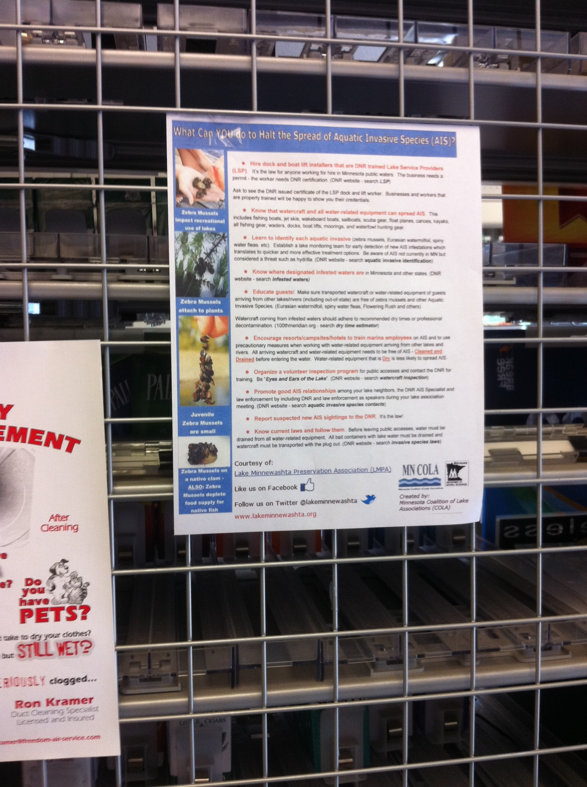

  - Educational signs at Lake Minnewashta fishing pier

Working with the Carver County Regional Park management, we had these highly visible educational signs installed on the public fishing pier. At an average of 10 visitors/day and 100 days, we estimate 1,000 potential carriers of zebra mussels and other invasive species were made aware of the threat and prevention.

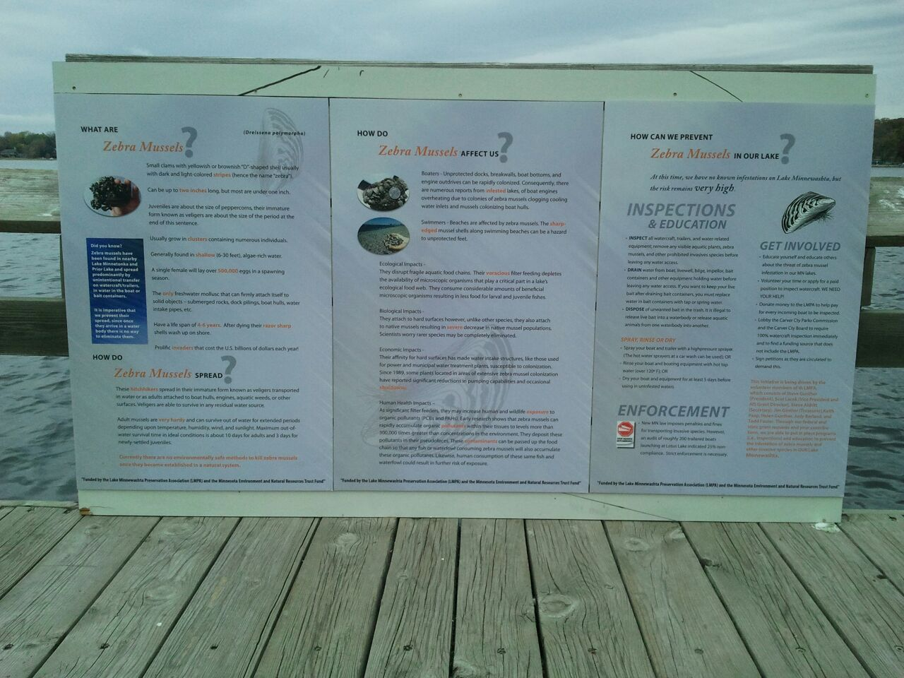

2. Design, produce and distribute zebra mussel/AIS brochure

2.1 AIS Brochure used in AIS Road shows

Using and editing material from the ANS Task Force (U.S. Fish and Wildlife Service), we published and distributed a double-sided brochure to all people we encountered during our AIS Road show (described below). With a total of 10 Road shows and approximately 800 people we talked with, over 1,000 brochures were distributed to interested parties for the prevention of AIS.

- AIS Events – AIS Road show

Perhaps our greatest achievement this summer was our AIS Road show, where we had a public display of AIS educational material, manned by one of our University of Minnesota interns and at least one LMPA Board member. The purpose was to go to heavily visited locations in the watershed on nice weekends and interact one-on-one with the public, educating them on the AIS issue and prevention efforts. We had a beach bag, boat floatie, and AIS brochure we distributed to those we interacted with. We held the Road shows at a total of 10 locations (described below), reaching an aggregate audience of over 10,000 people. Our Road Show evolved during the summer as developed materials were added to it.

Road show 1: Carver Regional Park

In cooperation with the Carver County Park management, we set-up our first Road show in the pavilion visited by campers in conjunction with a park event. Pictured are Ben Suker (one of our college interns, Judy Berland (Board Member), and Scot Lacek (Board V.P. and AIS Grant Program Director).

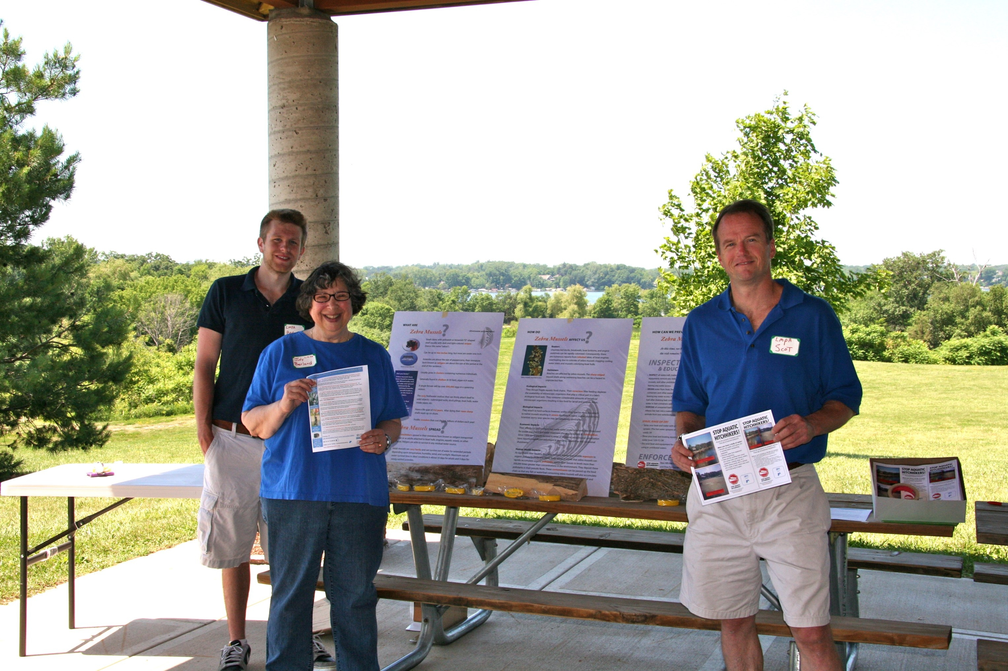

Road show 2: Excelsior Commons

To reach boaters and beach goers at this popular area on Lake Minnetonka, we set up our ever-expanding Road show in a very heavily trafficked area near the boat piers on a sunny Saturday. We included our LMPA Stop Aquatic Species banner, as well as our beach bags embossed with our lake association and the Stop Aquatic Species logos. Pictured are Ben Suker and Scot Lacek wearing our LMPA Stop Aquatic Species polo’s. We anticipate that over a 3-hour period, we had visibility to approximately 2,000 people and interacted with over 100 people, giving away our usable beach bag, floaties, and brochures. As Lake Minnetonka already has zebra mussels, interacting with those lake patrons would provide proactive, preventative efforts to stop the spread of AIS into Lake Minnewashta other uninfected lakes.

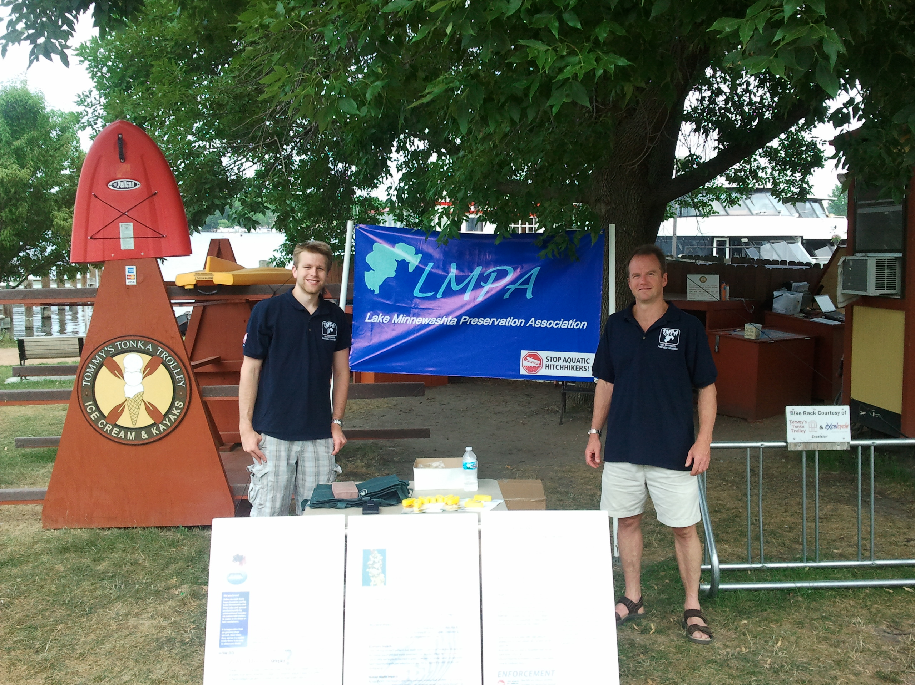

Pictured below are some lake Minnetonka boaters with our stylish beach bags promoting the Stop Aquatic Species message.

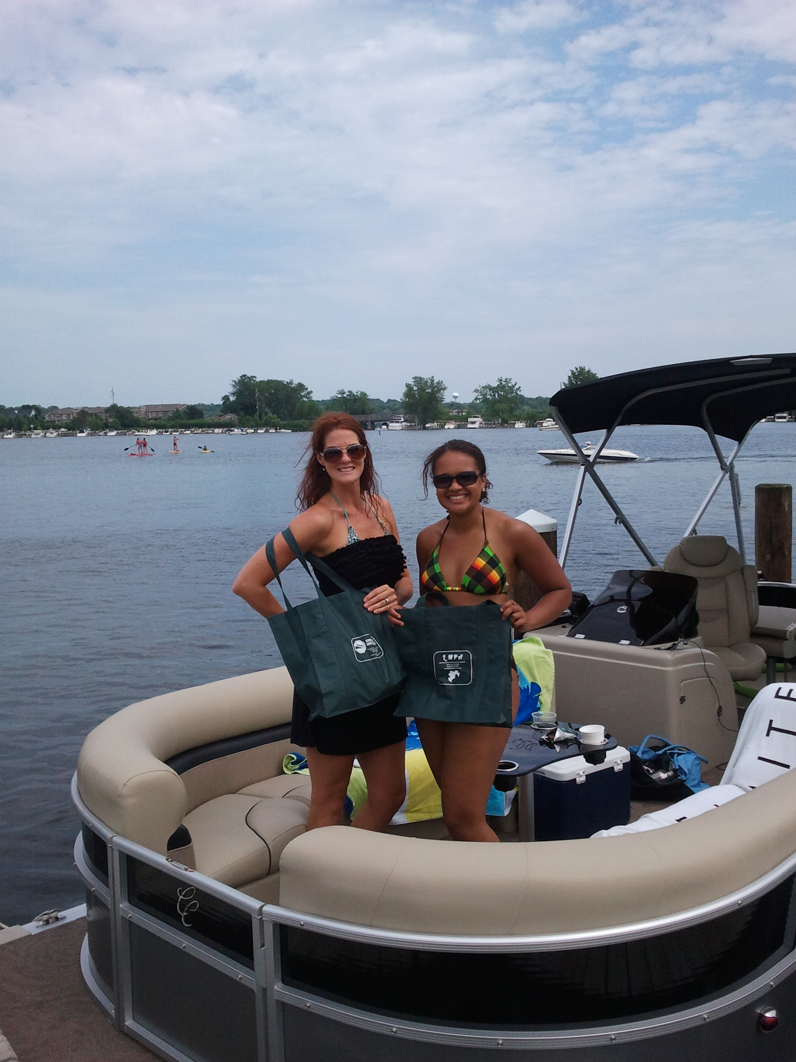

Road show 3: Chaska River Days

We brought our Road show to Chaska River Days to spread the word to over 3,000 visitors on a sunny Saturday. Pictured are Ben Suker, Randy Maluchnik, and Scot Lacek. Randy, a Carver County Commissioner, applauded our efforts to interact with the community to spread the word about AIS and prevention.

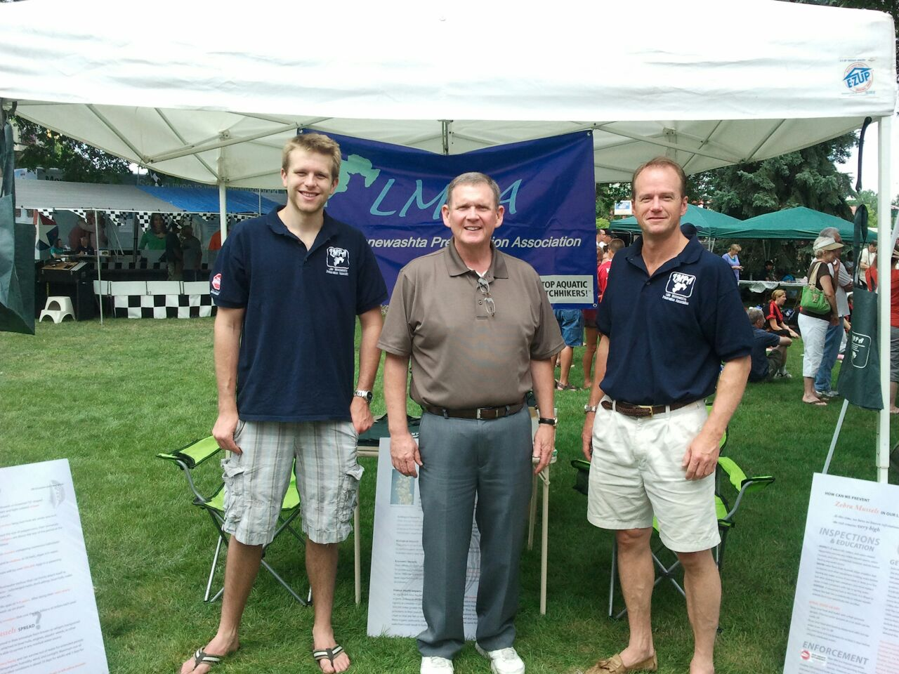

Road show 4: Excelsior Commons

Based on the success we had with the number of visitors on our previous Road show, we returned to the Excelsior commons on a sunny Saturday afternoon. We anticipate visibility to approximately 1,000 area visitors, and interacted with approximately 90 people over this 3-hour period. Pictured are Ben Suker and Scot Lacek.
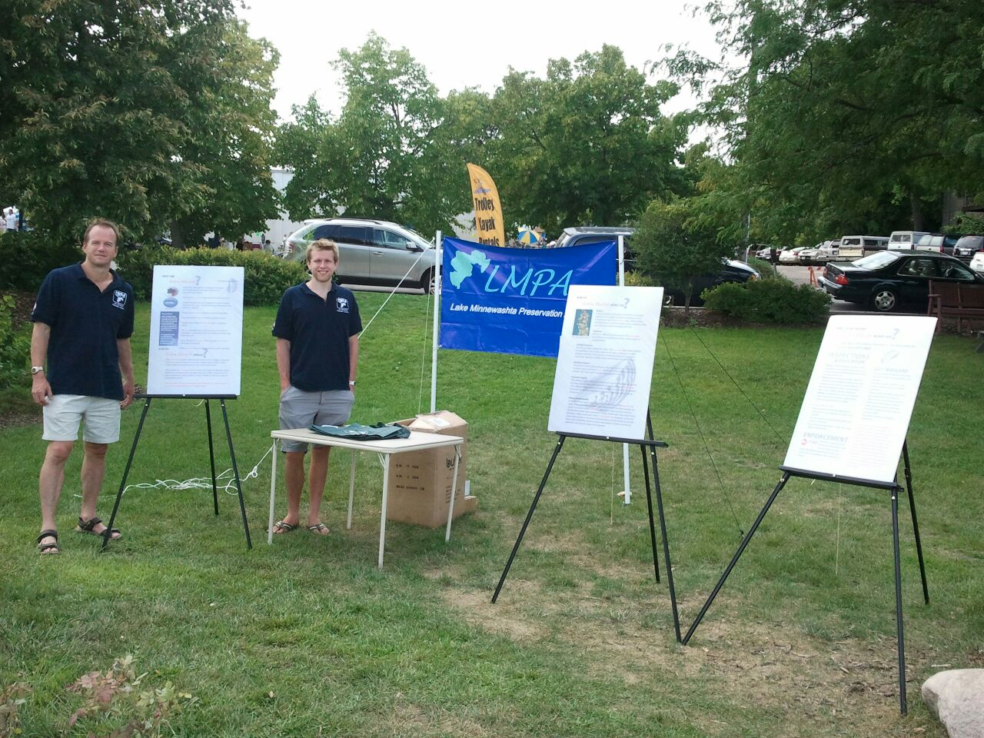

Road show 5: Pleasant Acres Private Boat Launch

We took our Road show to a private boat launch on Lake Minnewashta to ensure that boaters who don’t have visibility to the Carver Park Boat launch inspectors and AIS material were exposed to the AIS prevention message. Over 30 boats are launched here and regularly use this launch, so it poses a significant threat to potential introduction of AIS into the lake, particularly since there is no inspection. While traffic was light, we did engage with several boaters. Pictured are Scot Lacek, Ben Suker, and Judy Berland. Steve Gunther and Jim Ginther also helped us during this 3-hour period.
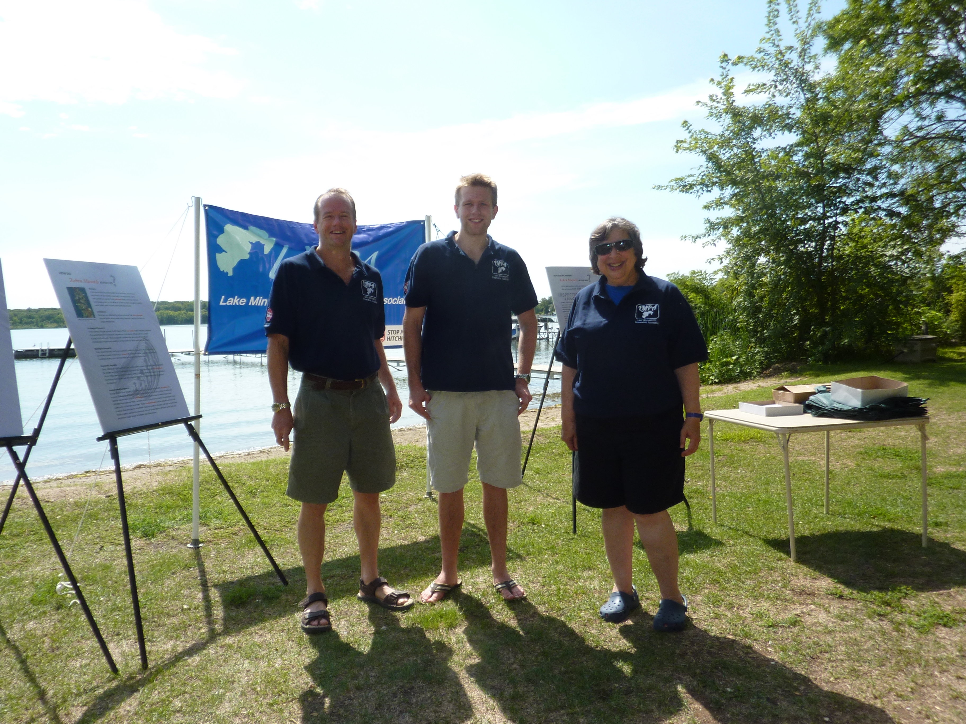

Road show 6: Maynard’s Restaurant on Lake Minnetonka (September 19)

We set-up our show next to Maynard’s restaurant the piers on Lake Minnetonka on a sunny Saturday. This very popular location gave us visibility to over 2,500 people over a 3-hour period. We had over 100 face-to-face discussions from restaurant patrons and boaters.

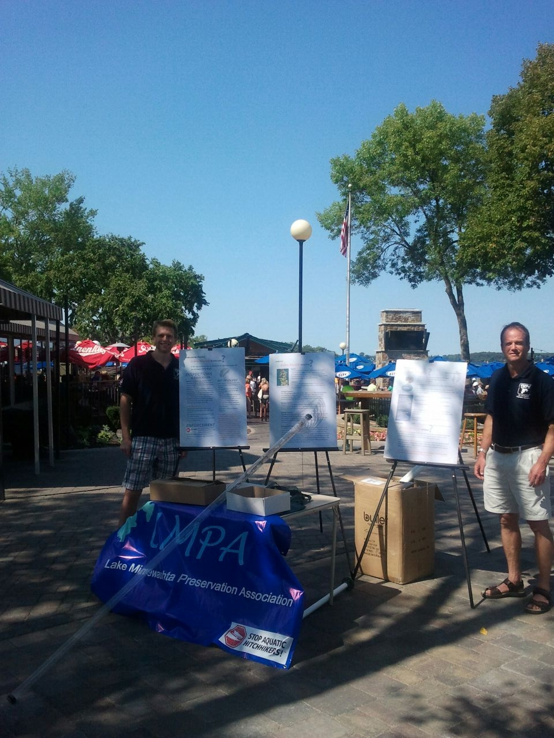

We also had Road shows on the Fourth of July and several other Saturdays, as well as a road show at a Chanhassen recreation center as parents were dropping off their children for soccer games
4. AIS Monthly Newsletters

To educate the Watershed community and keep them aware of our efforts, we published four AIS newsletters to Watershed citizens. The newsletters were designed to be educational, easy to read, and solicit involvement from the community via their comments on our social media links or volunteerism. We emailed each edition of the newsletter to approximately 300 email addresses on our records, sent it to residents without email, and published it on our LMPA website. I also submitted the topic of these articles to the local newspaper for publication.

Here is the text of our July AIS newsletter:

Aquatic Invasive Species (AIS) Awareness Program in Full Gear by the Lake Minnewashta Preservation Association (LMPA)

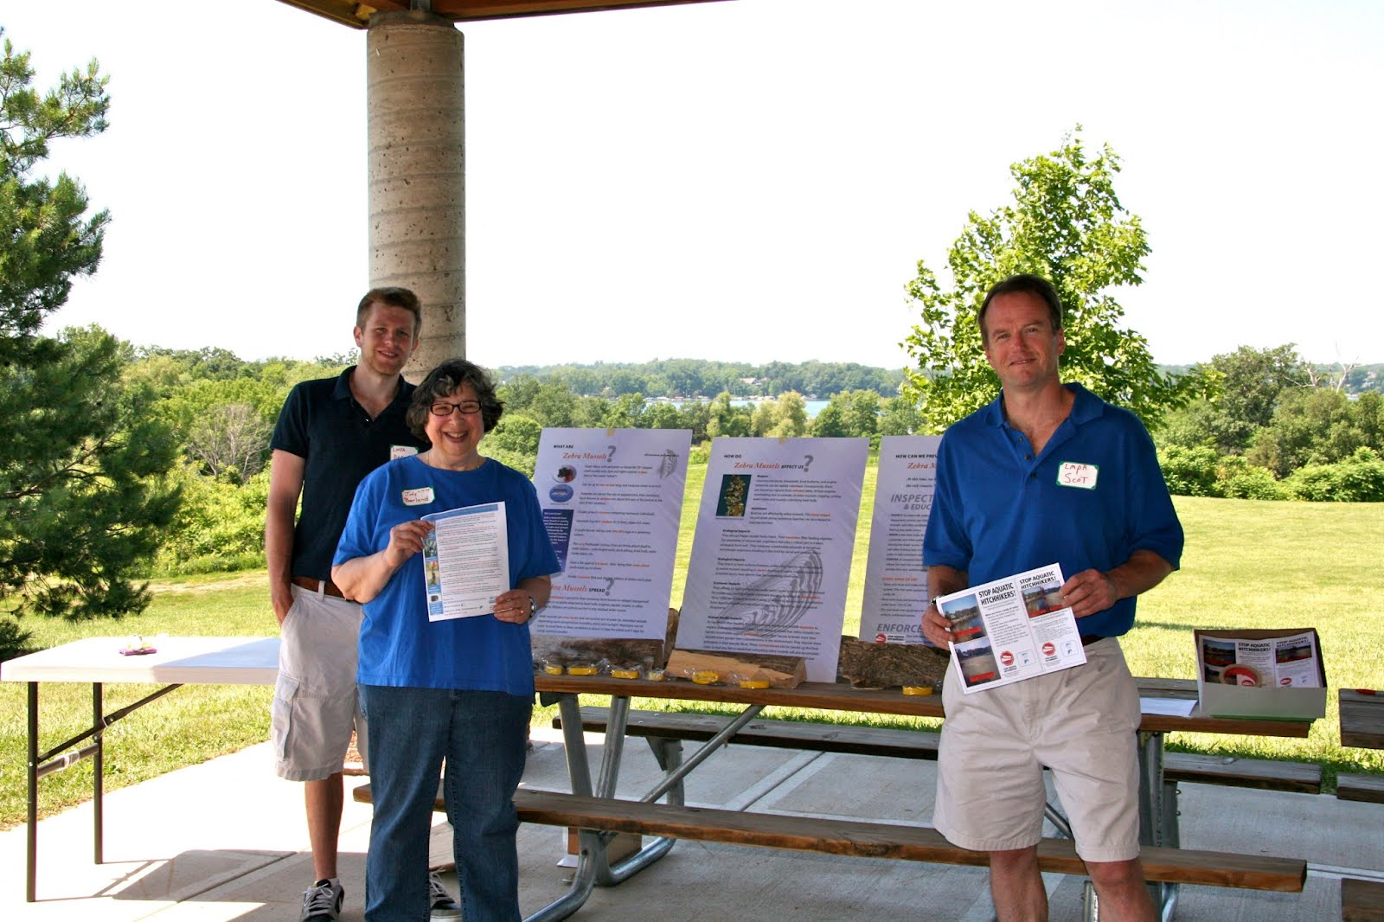

If you’re tired of reading and hearing about preventing aquatic species in Lake Minnewashta, Christmas, and Lotus lakes, that’s good news; lake associations and the Department of Natural Resources (DNR) are accomplishing their mission. This summer, the LMPA has added an ‘AIS Road show’ where our volunteers and interns will be staffing tables at events throughout the area, educating our lake area residents about aquatic species and their prevention. One particular goal of ours is to prevent the dreaded zebra mussel from entering our lake, benefiting current and future lake area residents.

Thanks to the LMPA’s grant request from the DNR and subsequent award of over $15,000, we’ve launched a comprehensive education and awareness campaign to blanket the area. We’ve already posted ‘Stop Aquatic Species’ posters at almost 100 local retailers. You’ll see our ads on gas station pumping station displays.

We’re updating our web site (www.lakeminnewashta.org) to provide educational material, links, and status of our activities. We will have display tables, educational materials, and even great give aways (such as beach bags and floating key holders) at over a dozen local community and park events this summer. You’ll see our University of Minnesota college inters, our Board members (listed below), and other volunteers manning these display tables and proactively engaging people in educational discussions. We’ll be presenting to adult groups, as well as children and girl and Boy Scout groups. We’re working with the board members from Christmas and Lotus Lake Associations to share ideas, maximize exposure and minimize costs. As you may have seen in previous articles, our President, Steve Gunther, has been very active in state and local government groups to advocate for zebra mussel prevention in our watershed.

If you would like to help us, we’re always looking for volunteers to help us greet the public, educate them, and answer questions at our various public events. Contact Scot Lacek, AIS Awareness Program Director (scotlacek@hotmail.com) for more information. We’re also looking for other lake area residents who would also be zealous about this fight as well as other lake issues to join the LMPA Board.

The LMPA is a volunteer, not-for-profit organization, its efforts supported by lake area LMPA member donations of over $250,000 over the last 10 years and grant awards, such as this.

Till’ Next Time

At the LMPA we hope to keep a constant conversation with the community and plan to be a part of various events over the summer, so don’t be afraid to get involved one way or another. Anything helps! Volunteers are needed! If you would like to help in our AIS Awareness program, such as representing us at one of our awareness events, give us your ideas on how best we can reach the community, or sponsor some of our efforts, please contact Scot Lacek, AIS Grant Program Director (scotlacek@hotmail.com).

Also, please don't forget this is the time of year when we count on your annual contributions to support our lake initiatives (see separate contribution form). We are also looking for LMPA Board member nominees. If you would like to find out more information about Aquatic Invasive Species and more specifically Zebra Mussels, please reference the Minnesota DNR Website (www.dnr.state.mn.us/).

Or better yet, check out our website (www.lakeminnewashta.org), Tweet us (twitter.com/#!/lakeminnewashta), or post a question on our Facebook page (http://on.fb.me/MJJpdH). We would love to start a conversation about keeping these VERMIN out of our Lake and get more people involved with our cause. We’re friendly and cordial, and we definitely won’t bite. Most importantly, have fun this summer, stay safe, and always remember to Float A Clean Boat.

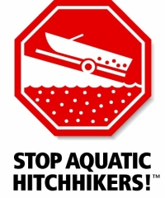
5. Ecard Blasts

To reach message density to our lake goers, we published 3 eblasts through the summer. Designed to be easy to read, visual, and educational, these were sent to approximately 300 email addresses on our records, reaching a total audience of 900 touches. We also published this on our website.

Here is our June eblast:

 | Web version | Update preferences | Unsubscribe
   |  | Like |  |  |  | Tweet |  |  |  | Forward

Lake Minnewashta Preservation Association

Hello!
We hope that you have been enjoying the weather and have been able to get out on the lakes! With summer fast approaching, more and more people will be enjoying themselves by boating, fishing, and having fun at the beach. Nothing says "Summer in Minnesota" than memories being made on the lakes, which is why we wanted to briefly give you some tips about Aquatic Invasive Species and effective methods to prevent theism from taking over our precious lakes.

Aquatic Invasive Species in Minnesota
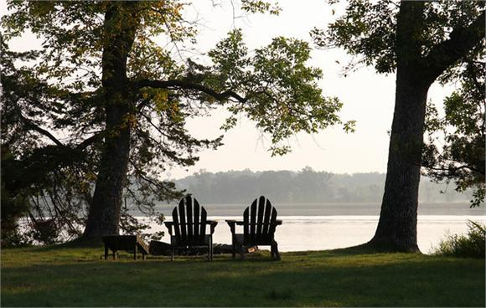
Minnesota prides itself on its beautiful lakes. Recently however, they have come under threat by Aquatic Invasive Species, such as zebra mussels. Currently there are 98 bodies of water that are infested with zebra mussels, including Lake Minnetonka. A large population of these large zebra mussels can destroy a lake's ecosystem and it is vital that we do everything in our power to stop them from spreading.

How can you Help?
Learn to identify what zebra mussels look like: As you can see a typical zebra mussel has a striped shell and are about as large as a fingernail
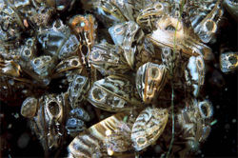
Hire dock and boat lift installers that are DNR Lake Services Providers
Inspect watercraft and all water-related equipment: Zebra mussels can spread on fishing boats, jet skis, wakeboard boats, sailboats, scuba gear, canoes, kayaks, and fishing gear.

It's the Law!
It is considered unlawful to transport zebra mussels and aquatic plants or to launch a boat with them attached.

Before leaving public accesses, water must be drained from all water-related equipment
All bait containers with lake water must be drained and watercraft must be transported with the plug out.
DNR fines can cost up to $1,000.
The biggest crime would be destroying one of our precious lakes!

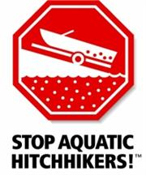

Edit your subscription | Unsubscribe instantly

6. Traditional Media Outreach

Several articles were submitted to the Chanhassen Villager and the Lakeshore Weekly to educate the community on AIS prevention. We also reached out to 8 television stations and 5 radio stations to communicate our AIS prevention message. While we had initial interest, we were not able to realize any broadcasts.

We continued to use of web site and email to broadcast our message en mass.

7. Web Site and Social Media Campaign

We initiated several changes to our LMPA website and Facebook sites to leverage social media. This included publishing our work to the website and keeping our twitter account active. Based on our hits, we realized over 2,000 interactions during the summer.

